- Approximation of area

1. Find the area under the graph of 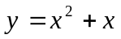between 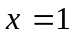and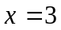. Using the mid ordinate rule with two trapezia. (3mks)
2. The table below shows some paired values of X and Y for a known curve.

X | 0.0 | 0.2 | 0.4 | 0.6 | 0.8 | 1.0
Y | 0.0 | 0.4 | 1.6 | 3.6 | 6.4 | 10.0

Estimate the area under the curve for the interval O<X<1 using
a) The mid – ordinate rule with five mid – ordinates. (4mks)
b) The trapezium rule with five Trapezia. (2mks)
c) If the exact area is ¹⁰/₃ square units.
Calculate the percentage error in the two estimates. (4mks)

3. Use trapezoidal rule to estimate the area bounded by the curve y = 8 + 2x – x² for -1 ≤ x ≤ 3
using 5 ordinates

4. (a) Using trapezoidal rule, estimate the area under the curve y = ½ x² – 2 between x = 2
and x = 8 and x-axis. Use six strips
(b) (i) Use integration to evaluate the exact area under the curve
(ii) Find the percentage error in calculating the area using trapezoidal rule

5. (a) Using trapezoidal rule, estimate the area under the curve y = ½ x² – 2 between x = 2
and x = 8 and x-axis. Use six strips
(b) (i) Use integration to evaluate the exact area under the curve
(ii) Find the percentage error in calculating the area using trapezoidal rule

6. The figure below shows the graphs of y = 2x + 3 and y = -2x² + 3x + 4
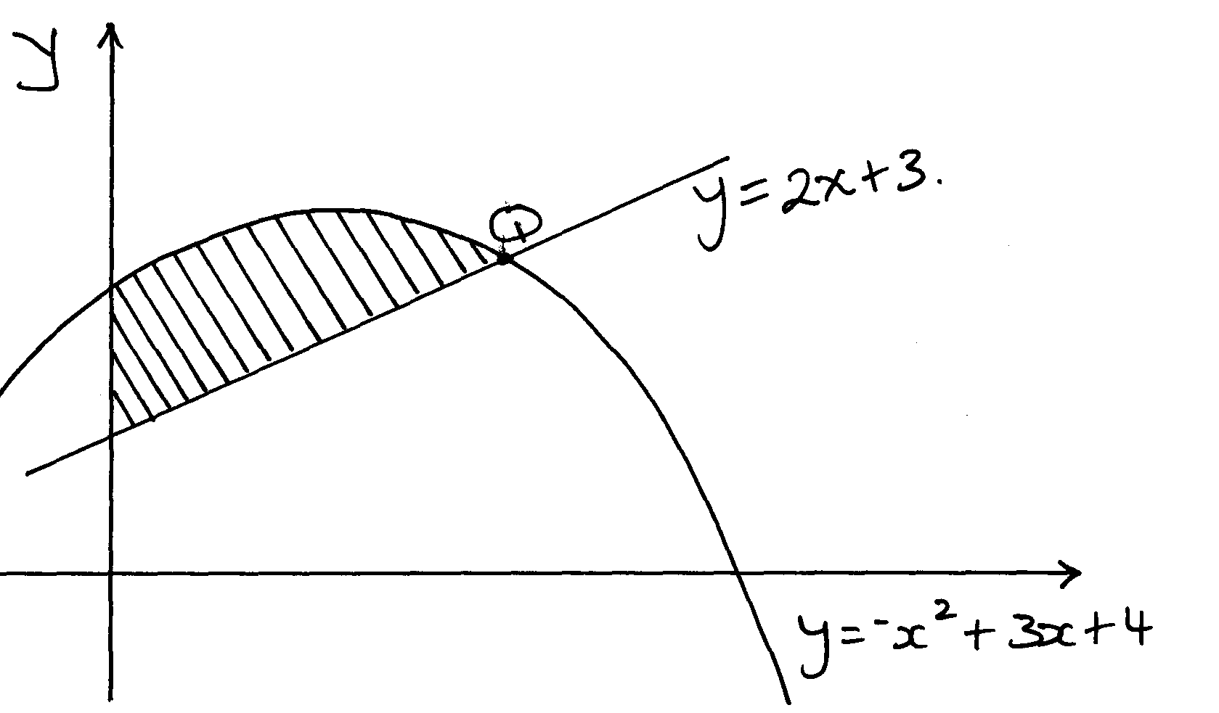
Q

(a) determine the co-ordinates of Q, the intersection of the two graphs
(b) Find the exact area of the shaded region

- The table below shows some values of the function; y = x² + 2x – 3 for -6≤ x ≤ -3

x | -6 | -5.75 | -5.5 | -5.25 | -5 | -4.75 | -4.5 | -4.25 | -4.0 | -3.75 | -3.5 | -3.25 | -3
y | 21 | 18.56 |  | 14.06 |  | 10.06 | 8.25 |  | 5 |  | 2.25 | 1.06 | 0
(a) complete the table
(b) using the completed table and the mid-ordinate rule with six ordinates, estimate the
area of the region bounded by the curve; y = x² + 2x – 3 and the lines y = 0 , x = -6 and x = -3
(c) (i) by integration find the actual are of the region in (b) above
(ii) Calculate the percentage error arising from the estimate in (b)

7. Complete the table below for y = 5x² – 2x + 2. Estimate the area bounded by the curve, the
x – axis, the lines x = 2 and x = 7 using the trapezoidal rule with strips of unit length.

x | 2 | 2.5 | 3 | 3.5 | 4 | 4.5 | 5 | 5.5 | 6 | 6.5 | 7
y | 18 |  |  | 56.25 | 74 |  | 117 |  |  | 200.25

